Bellabeat User Activity & Health Insights
Data Analysis Report
Jan Kodi
2025
Table of Contents
1.0 Business Task 2
2.0 Data Sources 3
3.0 Data Cleaning & Preparation 4
3.1 Data Consolidation 4
3.2 Data Cleaning 4
3.3 Data Limitations 4
4.0 Analysis Summary 6
4.1Trends in Smart Device Usage 6
4.2 Application of Trends to Bellabeat Customers 6
4.3 fluence on Bellabeat’s Marketing Strategy 6
5.0 Visualisation & Key Insights 7
Figure 1: abcd 7
Figure 2: absdfsdf 9
Figure 3: afdasfdfsdaf 10
6.0 Recommendations 11
7.0 Conclusion 12
8.0 Appendix 13

Table of Figures

No table of figures entries found.

1.0 Business Task

Title: Smart Device Usage Analysis for Bellabeat
Business Context:
Bellabeat, a high-tech manufacturer of health-focused smart products for women, aims to expand their presence within the global smart health device market. To achieve this goal, Bellabeat seeks to understand how consumers currently use smart devices to monitor and improve their health. These insights will guide marketing strategies for Bellabeat’s flagship product, Leaf.
Objective:
The project aims to identify which key health metrics – such as sleep, activity levels or calorie expenditure – most strongly correlating with improved overall health.
Key Questions:
- What are some trends in smart devices usage?
- How could these trends apply to Bellabeat customers?
- How could these trends hep influence Bellabeat marketing strategy?
Data Scope:
The analysis uses Fitbit Fitness Tracker Data by Möbius, covering sleep, activity and weight metrics collected between March 12, 2016, and May 12, 2016.
Deliverables:
- A Tableau dashboard visualizing user activity, sleep and health patterns
- A detailed executive report summarising findings, insights, and actionable recommendations for Bellabeat’s marketing team.

2.0 Data Sources

This project uses the publicly available FitBit Fitness Tracker Dataset by Mobius, to perform its analysis and construct applicable recommendations for Bellabeat. The dataset contains multiple data files pertaining to various user health metrics collected over the 90-day period. Within the scope of this project, only a selected subset of files is relevant to the analysis:

- daily_activity.csv
- Contains each participant’s daily activity data, includes total steps, total distance, active minutes etc.
- Used to analyse general activity levels and its relationship to weight and calorie expenditure.

- heartrate_seconds.csv
- Contains second-level heartrate values for each participant.
- Used to analyse heartrate patterns and its relationship to weight.

- hourly_calories.csv
- Contains hourly-level calorie expenditure values for each participant.
- Used to analyse calorie expenditure and its relationship to weight.

- hourly_intensities.csv
- Contains hourly-level activity intensities values for each participant.
- Used to analyse intensities patterns and its relationship to weight.

- minute_mets.csv
- Contains minute-level MET (Metabolic Equivalent) values for each participant.
- Used to analyse MET’s patterns and its relationship to weight.

- sleep_day.csv
- Contains each participant’s daily sleep duration, including minutes asleep and minutes in bed.
- Used to analyse general sleep patterns and its relationship to weight.

- weight_log_info.csv
- Contains each participant’s daily weight metrics, including BMI and fat percentages.
- Used to analyse changes in weight and as the dependent variable in weight -correlation analysis.

Each data file was imported and cleaned using either Excel or MySQL, then prepared for analysis. Final exploratory, statistical, and visual analyses were performed using Tableau.

3.0 Data Cleaning & Preparation

3.1 Data Consolidation

The initial step in preparing the FitBit Fitness Tracker Dataset by Mobius for analysis involved addressing the organisation of the raw data files. Upon downloading, the zip file was found to contain two separate directories: Fitabase Data 3.12.16-4.11.16 and Fitabase Data 4.12.16-5.12.16. Each folder housed datasets that corresponded to specific date ranges, resulting in the relevant data being split between the two directories.
To ensure a seamless analysis process, it was necessary to merge these dataset into a single file. This was accomplished by developing a Python script, merge_csv.py, which automated the combination of the data from both directories. By consolidating the datasets, subsequent data cleaning and analysis could be performed more efficiently and accurately.

3.2 Data Cleaning

Prior to analysis, each dataset underwent a comprehensive cleaning and transformative procedure using both Excel and MySQL. MySQL was utilised for handling larger files that surpassed Excel’s capacity. The process involved several key steps to ensure integrity and usability of the data.
- Removal of Duplicates: Duplicate records were identified and deleted, to maintain the accuracy of results and subsequently prevent bias analysis.
- Time and Date Formatting Corrections: Date format was converted to the conventional Australia format. Furthermore, text-based timestamps were converted to into datetime fields, ensuring uniformity for time-related analyses.
- Column Splitting: Fields such as ‘activityMinute’ originally consisting of both date and time information, were separated into distinct time and date columns to enable more precise time-series analysis.
- Standardisation of Units and Formats: Units of measurement, such as distance and weight were standardised and significant figures were aligned.
- Handling Missing or Null Values: Instances of missing data were carefully identified and managed.
- Data Type Conversions: Text fields were converted to numeric or datetime types as necessary, enabling calculations and aggregation to be performed during analysis.
- Standardisation of Column Names: Updating ambiguous or inconsistent field names to ensure reliable grouping and analysis.
This process produced a consistent, reliable dataset suitable for statistical analysis and visualisation in Tableau.

3.3 Data Limitations

A key limitation of this project is the substantial volume of missing data across all data files. This likely affects the ability to perform certain analyses and may influence the representativeness of the findings. As a result, the conclusions should be interpreted with caution.

4.0 Analysis Summary

4.1Trends in Smart Device Usage

Over the course of the 90-day analysis period, results indicated that there were no significant improvements in overall health across all users, as measured by metrics including weight loss, body mass index (BMI), and reductions in resting heart rate. However, a comparison between healthier and less healthy users revealed several notable trends:
- Users with lower body weight tended to take more steps and were generally more active than those with higher body weight. [add stat here]
- Healthier users, as defined by lower weight and BMI, slept more minutes on average compared to less healthy users. [add stat here]
- Users with higher body weight had a greater daily calorie intake than those who weighed less. [add stat here]
- Individuals with higher body weight also had fewer active days compared to their healthier counterparts. [add stat here]

4.2 Application of Trends to Bellabeat Customers

By applying these observed trends, Bellabeat can better anticipate how its customers might use their products. Understanding the differences among user types could inform the development of tailored features aimed at increasing engagement for each segment. For instance, specific functionalities could be designed to motivate less active users or to reward healthier behaviours, thus catering to the varying needs and habits of Bellabeat’s diverse customer base.

4.3 fluence on Bellabeat’s Marketing Strategy

Insights from these usage trends should be integrated into Bellabeat’s marketing strategy. By recognising the distinct profiles among users, the company can create targeted messaging and incentives that resonate with each group. This approach enables Bellabeat to address the unique motivations and challenges faced by different user segments, ultimately fostering greater product engagement and satisfaction.

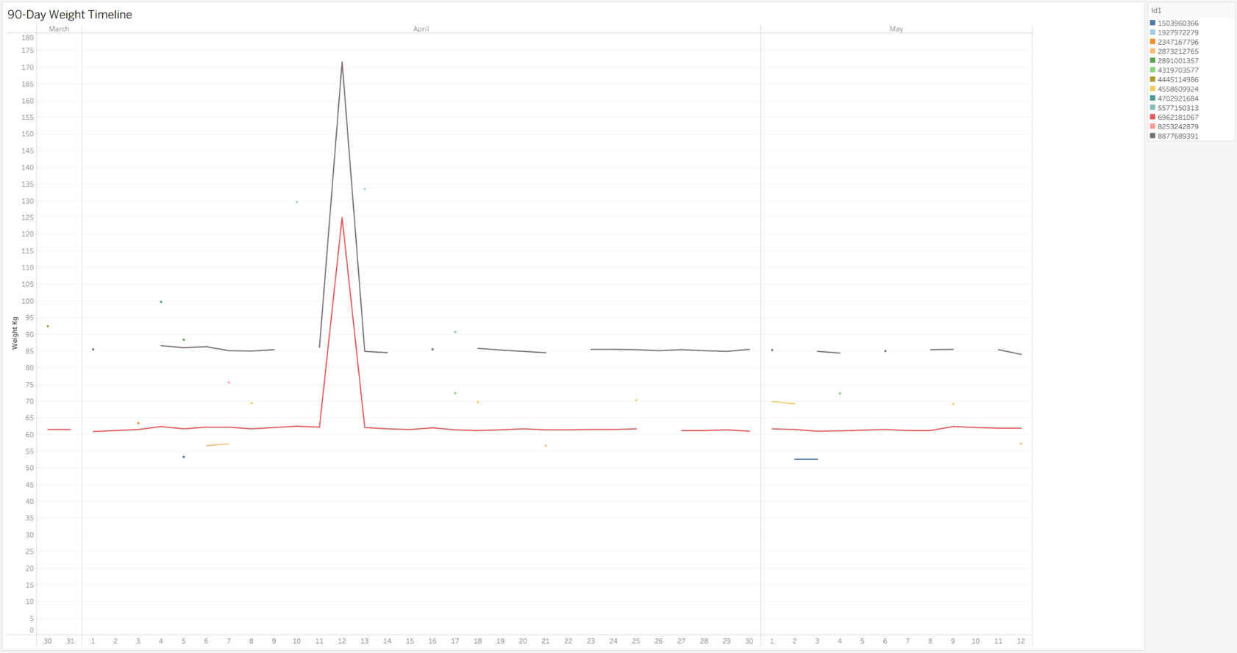
5.0 Visualisation & Key Insights

Figure 1: abcd NOT HEADING LOLOL

Analysis of 90-Day Weight Timeline
The graph depicting the 90-day weight timeline demonstrates a consistent, flat linear trend in users body wieght across all users throughout the 90-day period. Indicating, apart fromt the anomolies, no significant fluctuation in body weight during the analysis timeframe.

Anomalies in data Collection
Notable, two users - 6922181067 and 8877689391 – showed an unusual spike in their recorded weight on the 12th of April, where their weight had approximately doubled before returning to its original value within a single day. Such rapid and extreme changes are not physiologically possible and strongly suggest an input error. Therefore, these anomalies should be disregarded in the overall analysis.
Implication for user Behaviour
The persistent stabliltiy in user weight over the 90-day period is very unexpected, considering these are users using a fitness product marketed as a tool in which helps users get healthier. Where, typically one might anticipate more fluctuations in wieght among users engaging with fitness products over a significant period of time. However, the graph clearly states otherwise. Raising the question to why would users buy this product if not for health benefits. Exploring this aspect falls outside the scope of the current analysis and would require additional investigation.

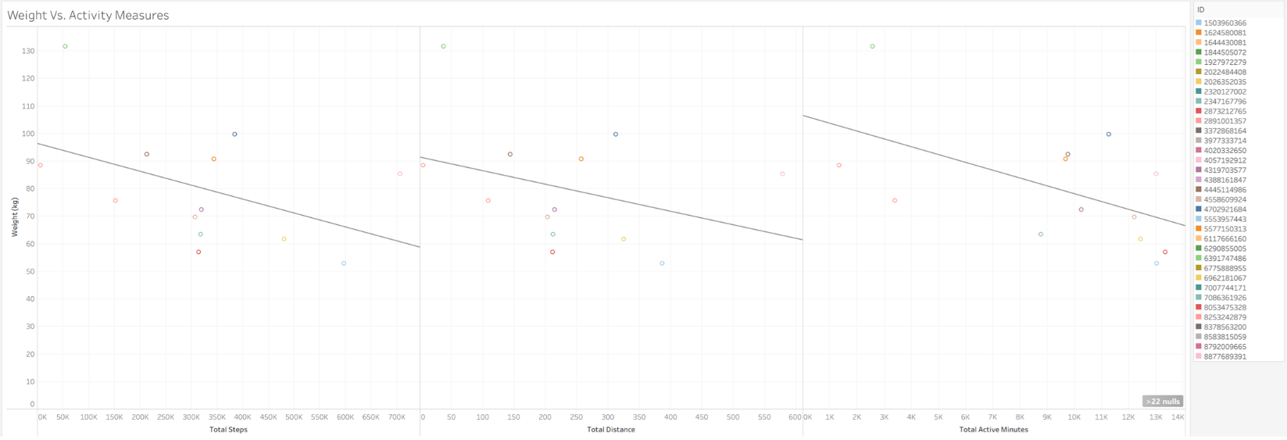

Figure 2: absdfsdf

Analysis of Weight Vs. Activity Measures.
The graph depicting weight in relation to the various activity measures – including total steps, total distance and total active minutes – shows a negative correlation between individual users’ weight and their levels of activity. However, due to the data points being widely dispersed, it indicates a weak relationship. This suggest that while increased activity may be associated with lower wight in users, activity alone does not strongly predict weight outcomes in this dataset.
It is important to interpret these findings with caution, as the dataset contains a small sample size and inconsistences in tracking behaviour undermining the reliability of the observed trend.
Implication for marketing team
These findings support the potential for categorising of users to form more effective marketing approaches. One possible segmentation could be:
- Category 1: Users who exceed the medically overweight threshold. Based on the data, these users are less likely to utlisied the products activit features extensively, Suggestting they mainly buy/use the product for a different purpose.
- Category 2: Users whose weight or BMI falls below the medically defined normal weight threshold. These individuals demonstrate higher engagement with the product’s activity functions.
Further investigation is necessary to fully understand how each category interacts with the product. This deeper insight would enable the development of tailored marketing strategies that address the specific needs and behaviours of each group.

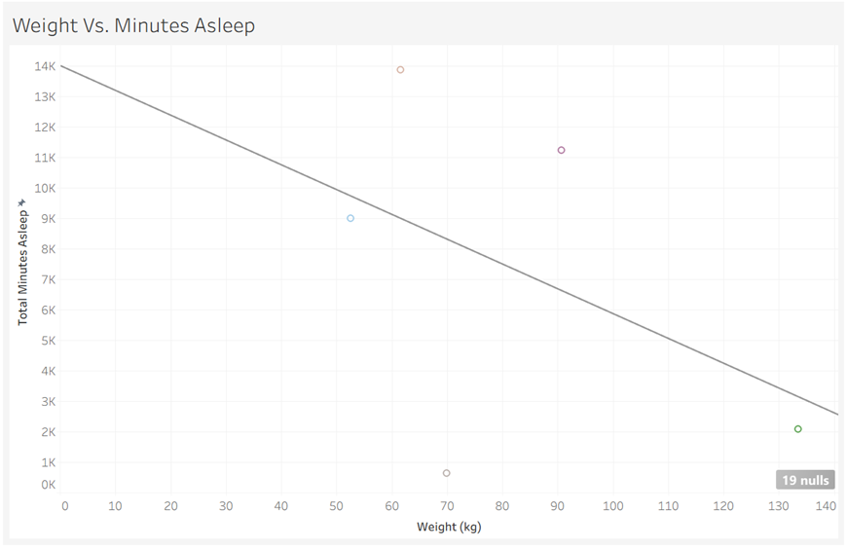
Figure 3: afdasfdfsdaf

The graph illustrates the relationship between user weight and total minutes asleep over the 90-day period. The data points show a wide spread, but the trend line slopes downward, indicating that users with higher body weights tended to record fewer minutes asleep overall. However, the pattern is weak due to the small number of users and the significant variability between individuals. Some lighter users logged comparatively low sleep totals, while some heavier users logged moderate amounts of sleep, suggesting no strong or consistent association. These inconsistencies imply that factors outside of weight—such as lifestyle, device wear habits, or sleep-tracking accuracy—likely influenced the recorded sleep duration. Overall, the trend suggests a possible negative relationship, but the data is too limited and scattered to draw reliable conclusions.

6.0 Recommendations

Based on the analysis of user behaviour and engagement data, the following recommendations are proposed for the Bellabeat marketing team:

Emphasise product aesthetics alongside health-tracking functionality
Insight:
Analysis indicates minimal changes in user weight over the 90-day period, suggesting that Bellabeat products may be used more as lifestyle or fashion accessories rather than as dedicated fitness or weight-management devices.
Recommendation:
To align with observed user behaviour and broaden market appeal, Bellabeat should position its products as aesthetically designed wearables that complement personal style while still delivering meaningful health-tracking capabilities. Marketing communications should emphasise design, versatility, and everyday wearability alongside core wellness features, reinforcing the brand’s positioning at the intersection of fashion and health technology.

Segment users based on behaviour patterns to improve personalisation
Insight:
User activity levels and engagement vary considerably across the dataset, indicating that users interact with Bellabeat devices in distinct ways and have differing wellness priorities.
Recommendation:
Bellabeat should segment users based on behavioural indicators such as activity patterns, engagement frequency, and wellness goals. These segments can be leveraged to tailor in-app experiences, notifications, and feature visibility to better align with user needs. Further analysis is recommended to identify which forms of personalisation are most effective for each segment, enabling more targeted and impactful product and marketing strategies.

Leverage sleep-related insights to enhance product value and marketing appeal
Insight:
Although the relationship between sleep duration and weight change was not strongly conclusive, observed trends suggest that sleep behaviour remains a meaningful dimension of user wellness.

Recommendation:
Bellabeat should enhance the prominence of sleep-tracking features by providing more personalised sleep insights and actionable recommendations. Additionally, highlighting sleep analytics in marketing materials could increase perceived product value. Positioning Bellabeat as a holistic wellness companion—rather than solely a fitness tracker—may attract a broader audience focused on overall wellbeing and long-term lifestyle balance.

7.0 Conclusion
This analysis explored user activity, sleep patterns, and engagement with Bellabeat products to identify behavioural trends and potential opportunities for the marketing team. While the dataset showed broad variation in user habits, the results highlighted several consistent themes. Activity levels and weight showed only weak relationships, suggesting that many users may not be using the device primarily as a fitness tool. Sleep patterns similarly displayed variability, indicating that additional factors beyond the tracked metrics influence user behaviour.
These findings emphasise the importance of understanding how different users interact with the product and recognising that engagement is shaped by diverse motivations and lifestyle preferences. By focusing on product aesthetics, implementing behaviour-based user segmentation, and leveraging sleep-related insights, Bellabeat can better align its marketing and product strategies with actual user behaviour.
Although the results are not strongly conclusive, they provide meaningful direction for further investigation and strategic refinement. Aligning product positioning and user experience with real-world usage patterns will allow Bellabeat to strengthen customer engagement, broaden its appeal, and support more informed decision-making moving forward.

8.0 Appendix

